Aug 22 2018

General Changes to scripts:

3 basepaths instead of 1

Importing regions into new EV files

Change to template:

Put Sv 38 raw pings T2 as associated with 38 kHz instead of 120 kHz

Doesn’t look like the euphausiid variables (Euphau 120 kHz_120-38 or CHU export hz120) is successfully pulling out euphausiids:

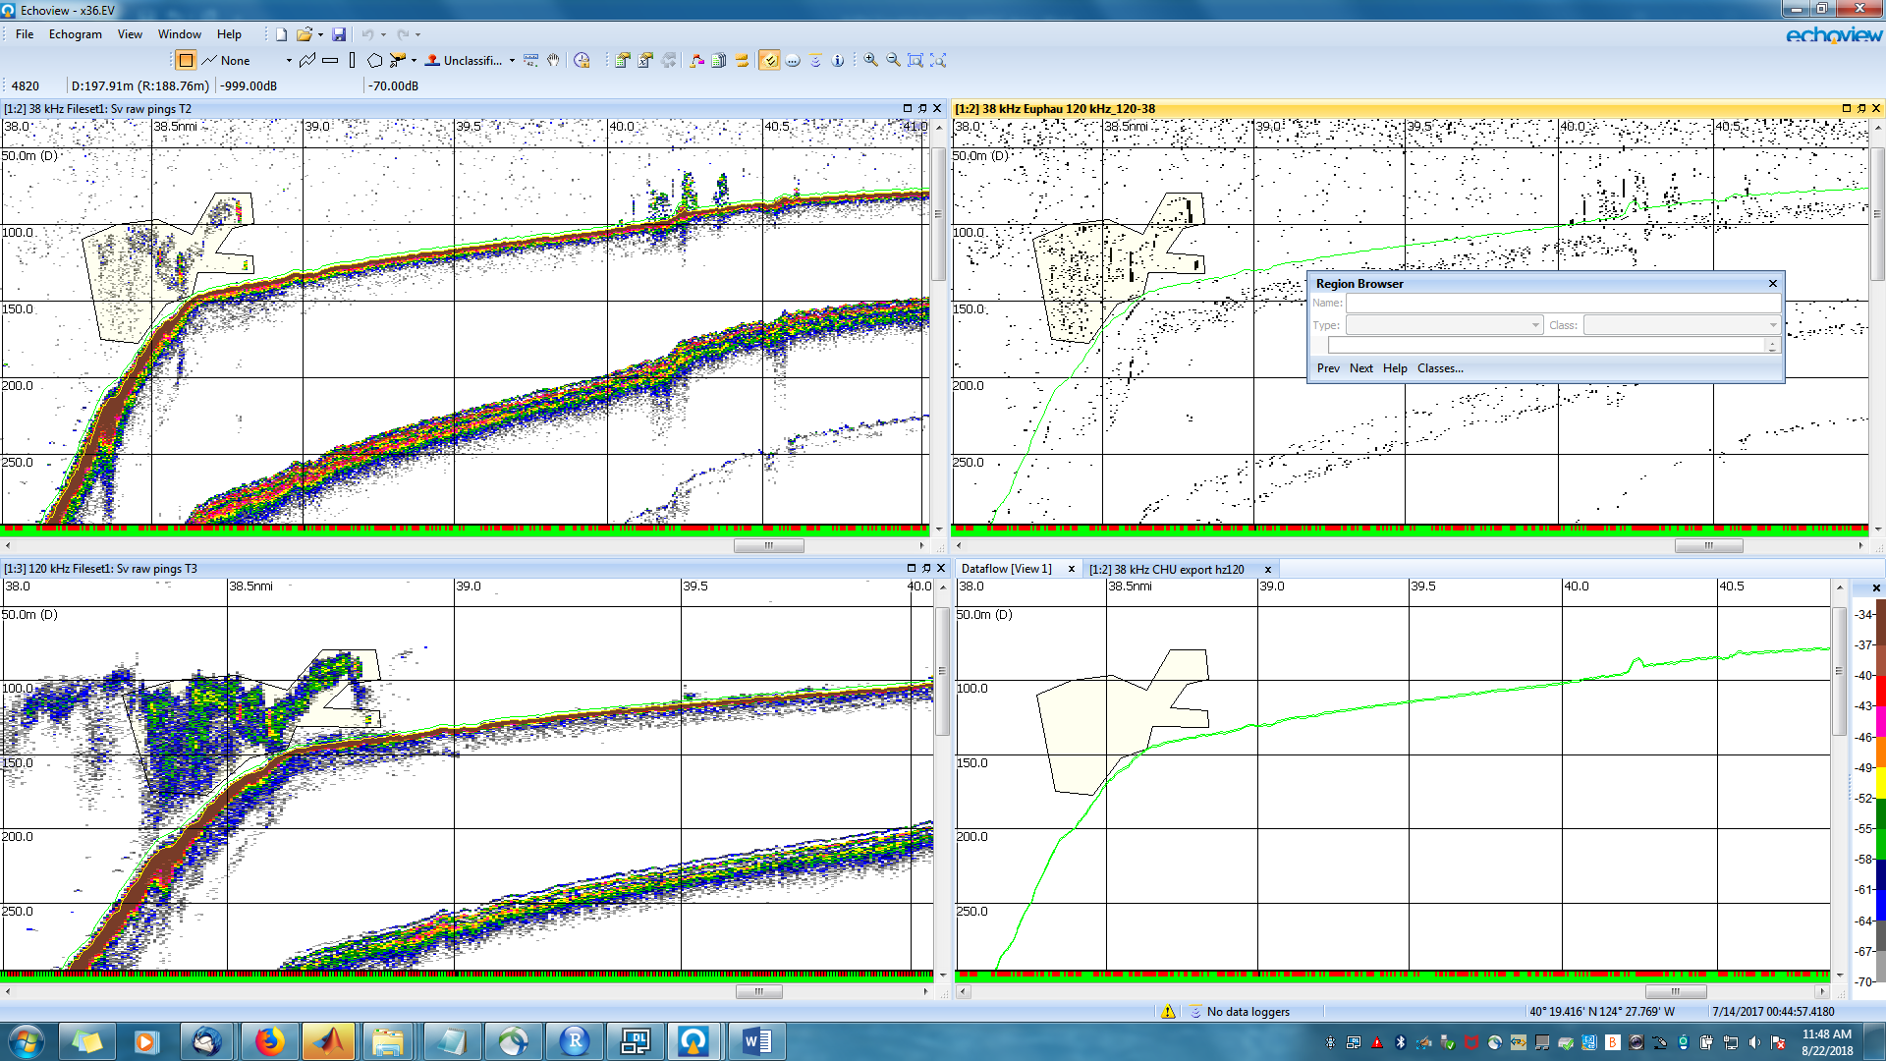

Fig. : X36 “plankton” region21

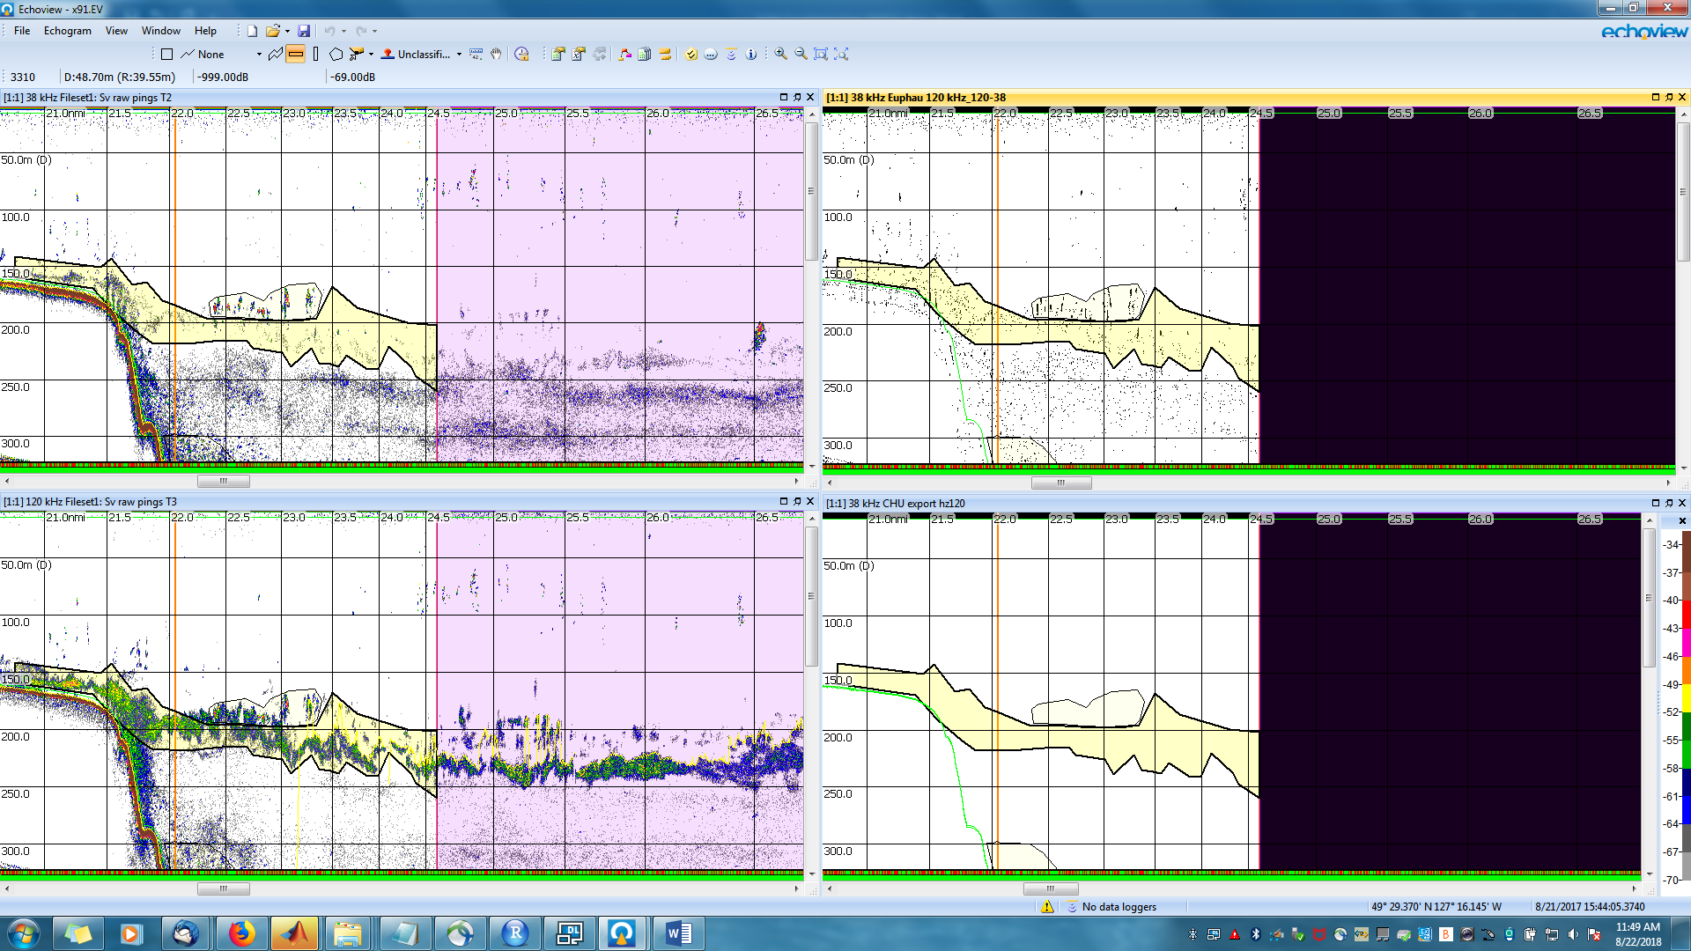

Fig. : X91, region 14

Okay, looks like the variable that starts the processed data process for 120 kHz is coming from T2, not T3.

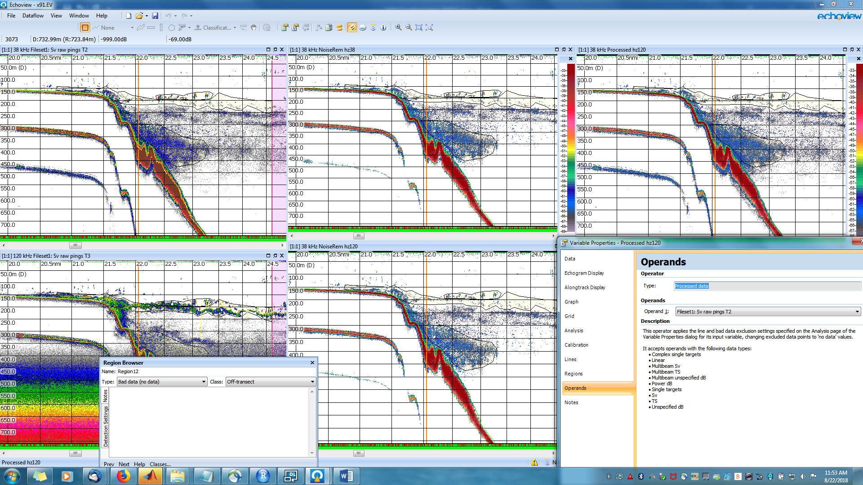

Fig. : X91, region 14

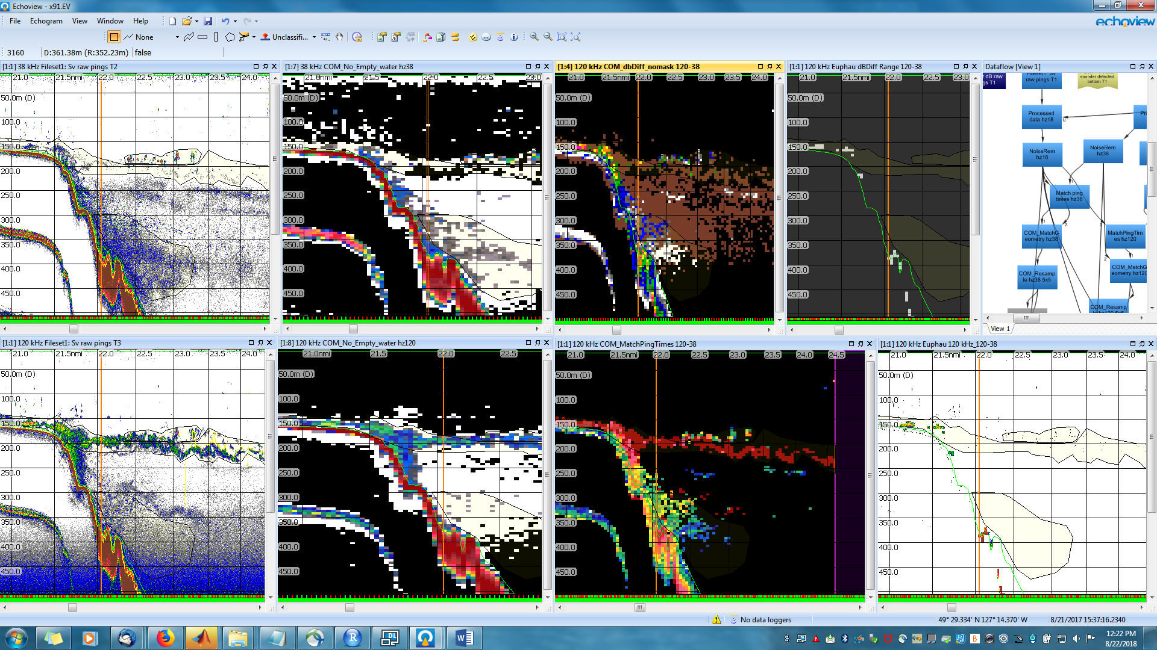

However, after fixing that, we still don’t get euphusiid coming out in the euphausiid variable. Looking back through the variable tree, I can see that although it looks like you can see euphausiids coming through as red near the end of the chain, they are actually -999. What looks like is going on is way back at the beginning when the dB difference is done, there is -999 in the 38 kHz Sv, so when the 38kHz is subtracted from the 120 kHz, it gives -999. There is thresholding in the 38 kHz processed data, which gives -999 for less than -70 dB. I don’t know the algorithm well enough to know how to solve the problem – perhaps by changing the threshold, but I don’t know.